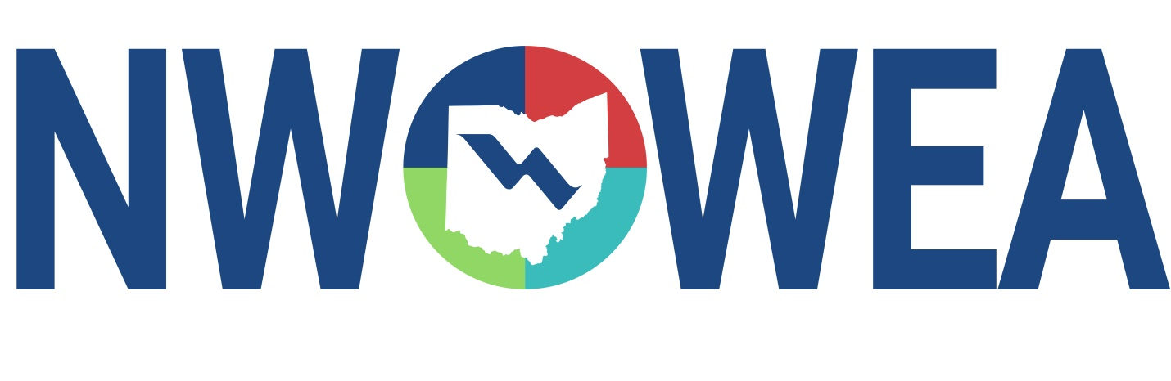

OWEA NW SECTION MEETING
March 27, 2024
Willow Bend Country Club
579 Hospital Drive, Van Wert, OH 45891

NWOWEA Section Meeting

8:00-8:30 Registration

8:30-9:15 Van Wert CSO LTCP Update and Basin Project

9:15 – 9:30 Break

9:30 – 10:15 Wastewater Treatment Upgrade at Cooper Farms Cooked Meats

10:15 – 10:30 Break

10:30 - 11:15 Ohio EPA DSW – Total Phosphorus

11:15 – 11:30 Business Meeting

11:30 – 12:30 Lunch

12:45 – 1:15 Van Wert CSO Basin and PS Tour
Directions at the Meeting – ½ Block NW of Bonnewitz & N. Jefferson Intersection

1:30 – 2:30 Cooper Farms Cooked Meats WWTP Tour
6793 US-127
Van Wert, OH 45891

The Northwest Section Would Like To Thank The Following Sustaining Sponsors:

Alloway Environmental Testing, Lima, OH
Baker and Associates, Ltd. Carey, OH
BissNuss, Inc., Westlake, OH
Dmytryka Jacobs Engineers, Toledo, OH
Jones and Henry Engineers, Inc., Toledo, OH
Mosser Construction, Fremont, OH
Peterson Construction Company
Poggemeyer Design Group, Inc., Bowling Green, OH
Smith Environmental, Columbus, OH
The Bergren Associates, Sylvania, OH
Waterworks Systems and Equipment, Inc., Lakeland, MI
Crown Battery Mfg. Co, Fremont, OH
Wessler Engineering, Inc., Bluffton, OH
Kokosing, Fredericktown, OH

