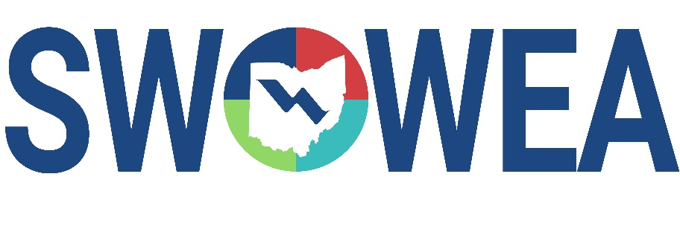

*Presents the 35th Annual*

##### Industrial Waste Seminar

**&**

**SWOWEA Section Meeting**

Thursday, January 23, 2025

Manor House

7440 Mason Montgomery Road

Mason, Ohio 45040

|  |
| --- |
| **CONTACT HOURS** |

Between 5-6 Contact Hours will be available.

|  |
| --- |
| **EXHIBITORS** |

The Seminar will include an Exhibitor area displaying various products,

equipment and services related to plant operations and maintenance.

|  |
| --- |
| **SEMINAR REGISTRATION INFORMATION** |

Early Attendee Registration (no later than 1/10/25) - $75

Late Attendee Registration/Walk In (after 1/10/25)- $85

Early Exhibitor Registration (no later than 1/10/25) - $300

Late Exhibitor Registration (after 1/10/25) - $400

Sponsorship - $150 (Your name and logo will be prominently displaced)

Registrations accepted online through 1/22/25. Walk-ins are welcome the day of event.

Pay at the door by cash or check; make checks payable to “SWOWEA”.

<Registration link to be added later>

***Evening Mixer: Join us after the Seminar for Refreshments and Snacks – Location TBD***